Spring MVC Structure

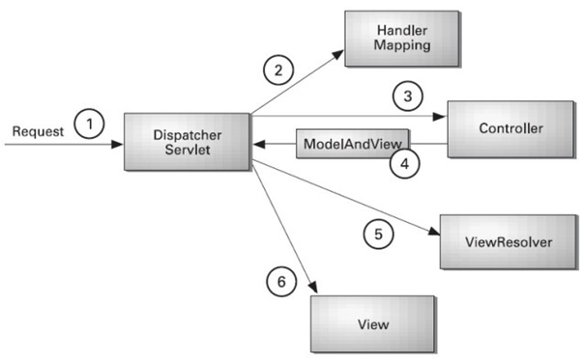

1. All the **incoming request** is receive and process by DispatcherServlet (project information xml file).
2. How Dispatcher will work is instructed by **handler mapping** (XML config file)
3. DispatcherServlet forwards the request to the controller.
4. Controller returns an object (ModelAndView).
5. DispatcherServlet **checks it** by view resolver **(XML file)**
6. After that DispatcherServlet invokes (call) the specified view component.